Esperanza Academy
Charter School

Technology Resource Student/Parent Handbook

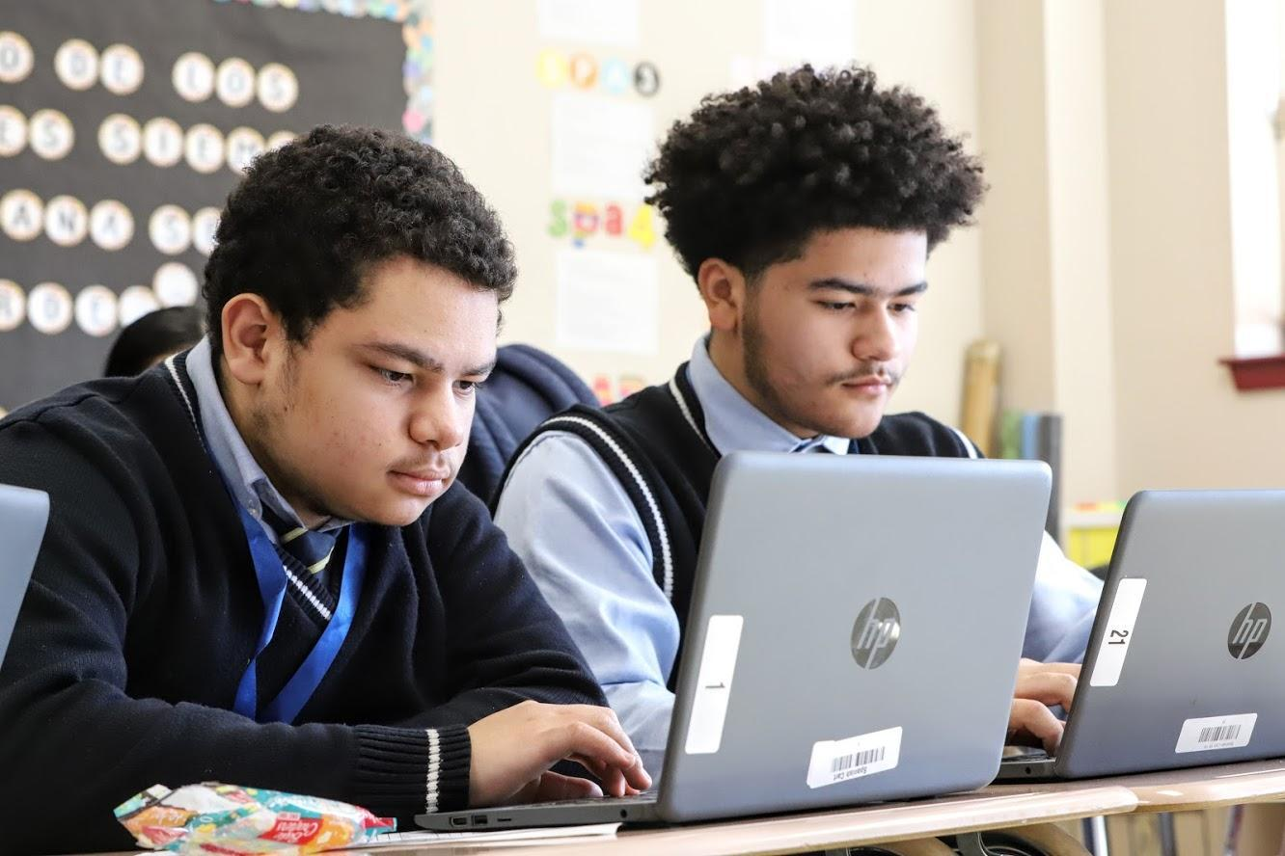

Overview
The use of technological and electronic resources is central to the delivery of Esperanza Academy Charter School’s educational program and there is a clear expectation that all equipment and resources shall be used exclusively for acceptable, educational use. It is the policy of EACS to maintain an environment that promotes ethical and responsible conduct in all electronic resource activities. With this privilege and extraordinary opportunity to explore resources are linked responsibilities for both the parent/guardian and for the student.

When signing the Student/Parent Chromebook Agreement, all parties are acknowledging that they understand and accept the information contained in this document.

EACS students and families must understand that:

1. All students are allowed access to electronic resources unless the school is notified in writing by the parent/guardian.
2. Electronic Devices are on loan to students and remain the property of EACS.
3. All users are accountable to all school, district, local, state, and federal laws.
4. All use of the Chromebook and network must support education.
5. All rules and guidelines are in effect before, during, and after school hours, for all EACS
Technology and electronic devices independent of location.
6. All files stored on EACS equipment are property of the district and may be subject to review and monitoring.
7. The term “equipment” or “technology” refers to Chromebooks, tablets, calculators, video cameras, batteries, power cord/chargers, and mice. Each piece of equipment is issued as an educational resource. The conditions surrounding this equipment can be equated to those of a textbook or a school-issued calculator.
8. Students are expected to keep the Chromebooks and tablets in good condition. Failure to do so may result in charges for repair or replacement.
9. The technology warranty (provided by the school) may cover hardware malfunction, not damage to the keyboard or display.
10. Students are expected to report any damage to their computer to the Technology Help Desk as soon as it happens (i.e. no more than 24 hours later).
11. All users are expected to follow existing copyright laws and educational fair use policies.
12. Students may only log-in under their assigned username. Students may not share their passwords with other students.
13. Students may not loan technology components to other students for any reason. Students who do so are responsible for any loss of components.
14. Any failure to comply with this handbook may result in disciplinary action as outlined by the Student Code of Conduct. EACS may confiscate a user’s device without notice at any time given reasonable suspicion.
Parent/Guardian Responsibilities
Esperanza Academy Charter School makes every effort to equip parents/guardians with the necessary tools and information to ensure the safe use of technology in the home. There are several responsibilities assumed by the parent/guardian. These are outlined below.

Sign the Student/Parent Technology Agreement

In order for students to be issued an EACS device, a student and their parent/guardian must sign the EACS Acceptable Use Policy (AUP) and Internet Safety Policy (ISP), found at the end of this handbook.

Accept Liability

The parent/guardian/student is responsible for the cost of repair or replacement on the date of the loss if the property or the equipment is:

• Not returned.
• Damaged (either intentional or due to negligence).
• Lost because of negligence.
• Stolen, but not reported to the school and/or police promptly.

Monitor Student Use

The parent/guardian must agree to monitor student use at home, and anywhere the student is completing schoolwork. The best way to keep students safe and on-task is to have a parent/guardian always present and involved.

During Distance Learning, students may be required to invest a great deal of time researching, web conferencing, and engaging in other education-related activities. Below are suggestions that may help to eliminate some of the distractions that come with the use of electronic devices and the Internet (i.e. Facebook, Twitter, YouTube).

Suggestions:

- Investigate and apply parental controls available through your Internet service provider and/or your
- wireless router.
- Develop a set of rules/expectations for chromebook use at home. Some websites provide parent/child agreements for you to sign.
- Only allow technology use in common rooms of the home (e.g. living room or kitchen) and not in bedrooms.
- Demonstrate a genuine interest in what your student is doing on any school device. Ask questions and request that they show you his or her work often.

Chromebook Care and Appropriate Use

Care of Device at Home:
• Charge the chromebook fully each night.
• Store the chromebook on a desk or table - never on the floor!
• Protect the chromebook from: extreme heat or cold, small children, Pets

Habits While Working:

• Center the chromebook on the desk.
• Keep food and drinks away from the chromebook.
• Lock the computer before walking away from it.
Prohibited Actions:

• Putting stickers or additional markings on the chromebooks, batteries, or power cord/chargers.
• Defacing EACS issued equipment in any way. This includes but is not limited to marking, painting, drawing or damaging any surface of the chromebooks.
• If any such action occurs, the student will be billed the cost of repair or replacement.

Support Student Safety
For schools and parents/guardians alike, student safety is always a high priority. The precautions described in this section are intended to help students be safe on the path to and from public locations (outside of the residence) where the student may be carrying his/her chromebook in order to complete schoolwork. Student safety always comes first.

Please review the following safety tips with your student:
● Walk to and from home in groups of two or more.
● Be aware of your surroundings, including people, vehicles, and wheeled devices.
● Let someone know when you leave and when you arrive home.
● Follow the safest route to your destination. Use main streets; avoid dimly lit areas, alleys, and shortcuts.
● If someone follows you on foot, get away from him or her as quickly as possible.
● If someone follows you in a car, turn around and go in the other direction.
● Always tell a parent/guardian, school official, or trusted adult in the event of an altercation.
● Turn the embroidered side of the case toward your body.
● If someone demands your device, give it to the person.

Technology as in Relation to the Code of Conduct/ Disciplinary Action

All EACS Code of Conduct rules and regulation will be held in relation to computer use. Any situations involving unacceptable and inappropriate use of any EACS-issued device or network will result in disciplinary action.

Examples of Unacceptable Use

Unacceptable conduct includes, but is not limited to, the following:

1. Using the network for illegal activities, including copyright, license or contract violations.
2. Unauthorized downloading or installation of any software including shareware and freeware.
3. Using the network for financial or commercial gain, advertising, or political lobbying.
4. Accessing or exploring online locations or materials that do not support the curriculum and/or are inappropriate for school assignments.
5. Vandalizing and/or tampering with equipment, programs, files, software, network performance or other components of the network; use or possession of hacking software is strictly prohibited.
6. Gaining unauthorized access anywhere on the network.
7. Revealing the home address or phone number of one’s self or another person.
8. Invading the privacy of other individuals.
9. Using another user’s account or password, or allowing another user to access your account or password.
10. Tampering with another individuals' chromebook, or removing their equipment from their designated area.
11. Coaching, helping, observing or joining any unauthorized activity while using a school device.
12. Posting anonymous messages or unlawful information on the network.
13. Participating in cyber-bullying or using objectionable language in public or private messages, e.g., racist, terroristic, abusive, sexually explicit, threatening, stalking, demeaning or slanderous.
14. Falsifying permission, authorization or identification documents.
15. Obtaining copies of, or modifying files, data or passwords belonging to other users on the network.
16. Knowingly placing a computer virus on a computer or network.
17. Attempting to access or accessing sites blocked by the EACS filtering system.
18. Downloading music, games, images, videos, or other media.
19. Sending or forwarding social or non-school related email.
20. Setting an inappropriate desktop background. Images that are prohibited may include but are not limited to; presence of guns, weapons, references to violence, pornographic materials, inappropriate language, alcohol, drugs, or gang-related symbols.
Chromebook Security

Two primary forms of security are chromebook security and Internet filtering. Each of the EACS chromebooks has a security program installed on it. EACS strives to strike a balance between the usability of the equipment and appropriate security to prevent the units from being damaged.

Chromebook Security:
Security is in place on the chromebook to prevent certain activities. These include downloading or installing software on the chromebooks, removing software, changing system settings, etc.

Internet Filtering at the School:
EACS maintains an on-site Internet filtering via a Web Filter. This program automatically filters all
student access to the Internet.

Damaged Equipment
Unexpected issues:
Occasionally, unexpected problems do occur with the chromebooks that are not the fault of the user (computer crashes, software errors, etc.). These issues will be remedied at no cost. The student should follow the Troubleshooting and Swap policy mentioned below. However, if after examination it is determined that the computer crash was an effect of negligence or inappropriate use of the chromebook, the student will be subject to disciplinary action and/or the cost of repair or replacement of the unit.

Troubleshooting and Swap

1. Student attempts to fix the problem.
• Always try restarting the chromebook as the first step in troubleshooting.
• If an error message appears on the screen, write the message down or take a screenshot to send to the Technology Help Desk at helpdesk@neacademy.net
• Students are reminded not to waste too much time trying to resolve the issue, as it will take time away from their course work. Always ask if you need help!
2. If unable to resolve the issue, students should immediately email the Technology
Help Desk. If a student is unable to email, please ask a teacher, counselor, or DOSD for assistance.
3. If the issue cannot be resolved via email or phone, the student will be asked to return the chromebook to the learning center for repair.
4. If the issue is deemed to be caused by negligence (if damaged), or as a result of improper use of the chromebook, students will be held responsible and subject to disciplinary action and the cost of repair or replacement.

Damage:
After investigation by the Technology Coordinator and IT specialist, if the chromebook is deemed to be
intentionally or negligently damaged by the student, the student will be subject to discipline and the cost of repair or replacement.
Lost or Stolen Equipment
If any equipment is lost, the student or parent must report the loss immediately to the Technology
Coordinator.

Financial Responsibility:
The circumstances of each situation involving lost equipment will be investigated individually.
Students/families may be billed for damaged or lost equipment.

Stolen Equipment

Reporting:If equipment is stolen, a police report must be filed and the student or parent/guardian must provide a copy of the report to the school in a timely manner.

If there is not clear evidence of theft, or the equipment has been lost due to student negligence, the student and parent will be responsible for the full cost of replacing the item(s).

Failure to report the theft to the proper staff and follow the proper filing procedure may result in a bill for full replacement cost to the student.

Financial Responsibility:
After investigation and review of proper documentation, if a chromebook is deemed stolen, EACS will cover
its replacement. The student will be issued a replacement computer at no cost to him/her.

Replacement Costs

EACS strives to repair and return damaged units as quickly as possible. We have taken it upon ourselves to repair two of the most common issues in-house. If a student damages an EACS issued chromebook's display (screen) or keyboard the repair will be done at the school. Ultimately, this reduces the cost of repairs to a machine that has been damaged in this manner.

If it is determined that the chromebook will need more extensive repairs, other than the damage mentioned above, EACS will send the damaged machine to an authorized repair specialist for repairs. These repairs will vary in cost, and must be paid for by the student and parent.

In the event that the unit is deemed beyond repair, the student and parent will be held responsible for the full cost of a replacement unit. The school may set up payment plans to clear bills, if needed.
(Cost to be provided after investigation.)

Important Contact Information
In the event that you may need assistance with your technology, please use the following contact information. It is our goal at EACS to provide appropriate assistance in a timely fashion.

Esperanza Academy Charter School
Helpdesk Support

Contact- Helpdesk@neacademy.net

Jeffery Obiagwu – IT Coordinator - Cobiagwu@neacademy.net

Hassan Yapul – IT Intern -hyapul@neacademy.net

Blayer Pointdujour – Technology Manager – Bpointdujour@neacademy.net
Video Conference Protocols and Best Practices
Each student chromebook is equipped with a webcam. Webcams are to be used for educational purposes only, under the direction of a teacher. Examples include:
• Recording videos or taking pictures to include in a project.
• Recording a student giving a speech and playing it back for rehearsal and improvement.
• Participating in a live, virtual class lesson with a teacher present.

Please note that installing unauthorized Internet calling/video-conferencing software is prohibited on EACS chromebooks. Software for using the webcam is already installed on the EACS chromebook.
Student Guidelines for Video Meetings
1. Students should be respectful and considerate of all members in the meeting.
2. Students should follow all the rules and procedures outlined in the Student Handbook during Video meetings.
3. Students should try not to move their device around while in a session. Music should be off in the background and students should ask family members to try to not enter the view of the camera during class.
4. Be sure you sit in a well-lit and quiet place.
5. Be mindful of what is going on behind you.
6. Ensure you have a strong internet connection before the meeting.
7. If your internet speed is slow, try bringing your computer or mobile device closer to the WIFI router or access point in your home or office. For the strongest connection, connect your device directly to your Router.

How to Access Settings for Zoom
- Go to Zoom.us, click sign in using Google, select your school Gmail account or in Zoom applet on your computer, click on Gear symbol in upper right-hand corner

Acknowledgement of Receipt and Review

Each parent/guardian of a student and each student enrolled in Esperanza Academy Charter School must sign and return this page to the student’s homeroom teacher. This page serves as acknowledgement that you have received and reviewed the following documents with your child:

- Parent/ Student Handbook
- Student Code of Conduct
- Technology Handbook

By signing below, I acknowledge that I have read and discussed the aforementioned documents and their content with my child.

Parent’s/Guardian’s name: _______________________________

Parent’s/Guardian’s Signature: ___________________________________ Date _______________

Student’s Name :___________________________________ Homeroom Teacher:__________________

Student’s Signature : _______________________________________ Date__________________

